NYSSLS Daily Lesson Plan
Instructional Unit: Big Bang |  |  |  |  | Period(s) of Unit: |  |  | Date:
Materials/Resources/Links: |  |  |  |  |  |  |  | Course: Regents ES
Special Notes for Lesson:
Standards: Construct an explanation of the Big Bang theory based on astronomical evidence of light spectra, motion of distant galaxies, and composition of matter in the universe.
Science and Engineering Practices  Constructing Explanations and Designing Solutions Constructing explanations and designing solutions in 9–12 builds on K–8 experiences and progresses to explanations and designs that are supported by multiple and independent student-generated sources of evidence consistent with scientific ideas, principles, and theories. ♣ Construct an explanation based on valid and reliable evidence obtained from a variety of sources (including students’ own investigations, models, theories, simulations, peer review) and the assumption that theories and laws that describe the natural world operate today as they did in the past and will continue to do so in the future. (HS-ESS1-2),(HS-ESS1-7)  Science Models, Laws, Mechanisms, and Theories Explain Natural Phenomena  A scientific theory is a substantiated explanation of some aspect of the natural world, based on a body of facts that have been repeatedly confirmed through observation and experiment and the science community validates each theory before it is accepted. If new evidence is discovered that the theory does not accommodate, the theory is generally modified in light of this new evidence. (HS-ESS1-2) |  |  | Disciplinary Core Idea(s)  The study of stars’ light spectra and brightness is used to identify compositional elements of stars, their movements, and their distances from Earth. (HS-ESS1-2),(HS-ESS1-3) ♣ The Big Bang theory is supported by observations of distant galaxies receding from our own, of the measured composition of stars and non-stellar gases, and of the maps of spectra of the primordial radiation (cosmic microwave background) that still fills the universe. (HS-ESS1 2) ♣ Other than the hydrogen and helium formed at the time of the Big Bang, nuclear fusion within stars produces all atomic nuclei lighter than and including iron, and the process releases electromagnetic energy. Heavier elements are produced when certain massive stars achieve a supernova stage and explode. (HS-ESS1-2),  Atoms of each element emit and absorb characteristic frequencies of light. These characteristics allow identification of the presence of an element, even in microscopic quantities. (secondary to HS-ESS1-2) |  |  |  | Cross Cutting Concepts  Energy cannot be created or destroyed only moved between one place and another place, between objects and/or fields, or between systems. (HS-ESS1 2)
Performance Level
NYS Level 5 | NYS Level 4 |  |  | NYS Level 3 |  | NYS Level 2 |  | NYS Level 1
Construct an  explanation of the  Big Bang theory  using multiple  sources, based on  valid and reliable  evidence of energy  from light spectra,  motions of distant  galaxies, and the  composition of  matter in the  universe (Cosmic  Microwave  Background  Radiation  (CMBR)). | Construct an  explanation of the  Big Bang theory  based on  astronomical  evidence of light  spectra, motion of  distant galaxies,  and composition  of matter in the  universe. |  |  | Construct an  explanation of the  Big Bang theory  based on  astronomical  evidence of light  spectra, or motion  of distant galaxies,  and/or the  composition of  matter in the  universe (Cosmic  Microwave  Background  Radiation  (CMBR)). |  | Identify the  explanation, that  supports the Big  Bang theory based  on astronomical  evidence of light  spectra or  motion of distant  galaxies or  the composition of  matter in the  universe (Cosmic  Microwave  Background  Radiation  (CMBR)). |  | Identify the  evidence, from  those provided,  that supports the  Big Bang theory,  based on  astronomical  evidence.
Clarification Statement Emphasis is on the astronomical evidence of the red shift of light from galaxies as an indication that the universe is currently expanding at an accelerated rate, the cosmic microwave background as the remnant radiation from the Big Bang, and the observed composition of ordinary matter of the universe, primarily found in stars and interstellar gases (from the spectra of electromagnetic radiation from stars), which matches that predicted by the Big Bang theory (3/4 hydrogen and 1/4 helium).] |  |  |  |  |  | Assessment Boundary
Connection to Anchoring Phenomenon: https://youtu.be/D93B-J8J-94?si=4R7kZEaWL-MVCsQQ
Brain Pop Big Bang Video

Essential Question(s):
Instructional Strategies & Learning Tasks: Engage, Explore, Explain, Elaborate, Evaluate
Engage: Anchoring phenomenon, demonstration; observations of images, video clip or data… |  | https://youtu.be/_qFacTKNyCA?si=CS6qVsTYjEwxtI6M  NOVA Origins Back to the Beginning  Beyond Hubble the Telescope of Tomorrow - video Dailymotion  https://youtu.be/W1ZQ4JBv3-Y?si=4O60ZL5cZ1yKnQTS  How does fusion power the sun video
Explore: Students investigate, experiment, hands-on activity…. |  | Create an anchor chart to model the beginning of the Universe  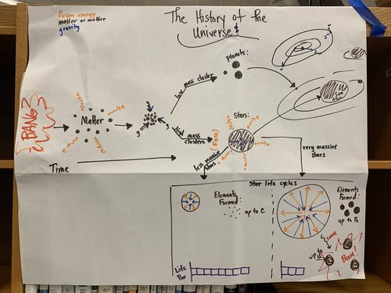  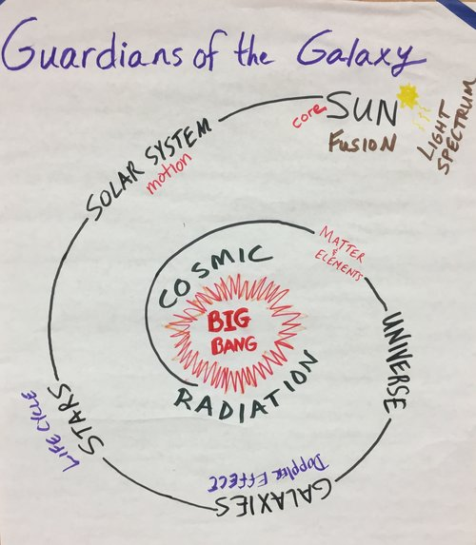  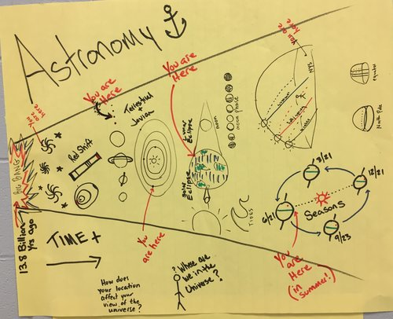  Cosmic timeline project – Create a timeline that traces the history of the universe from the big bang to present day. Each group is responsible for researching and presenting information on a specific era, such as the formation of the first atoms, creation of stars and galaxies, or development of the solar system.  Big Bang article & questions
Explain: Students share their observations and evidence to explain their understanding…possible whole group/class discussion… |  | Earliest atoms  Nuclear fusion  Evidence of Big Bang
Elaborate: Students apply the science concepts they’ve just learned… |  | Worksheets – Comparing spectra, red shift/blue shift  What is Your Cosmic Connection to the Elements? (nasa.gov)
Evaluate (Formative Assessment): Student learning is evaluated. |  | Include in unit exam

Copy and paste student worksheets below:

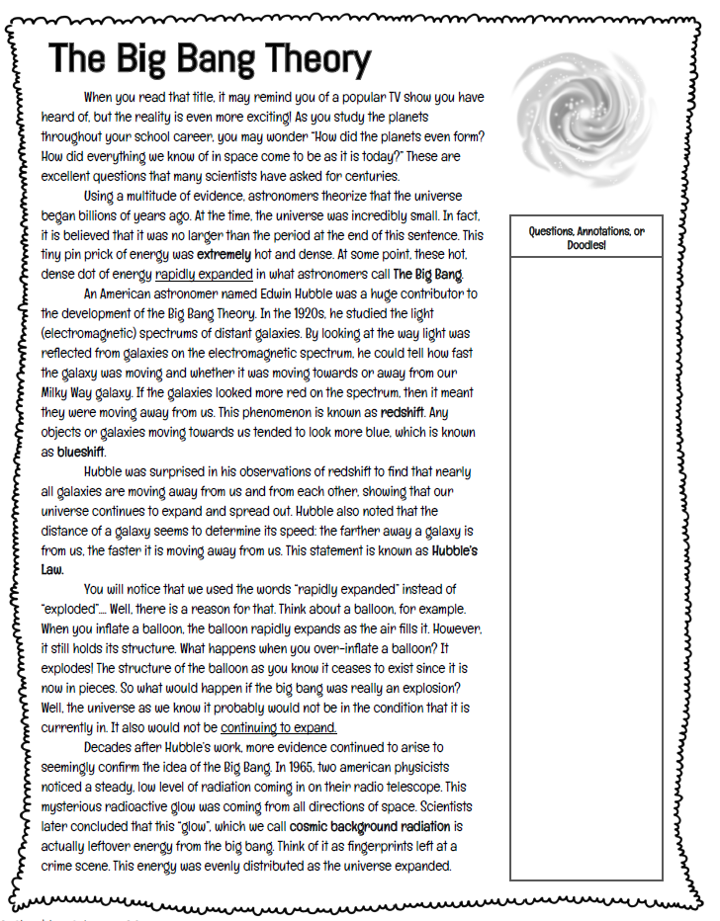
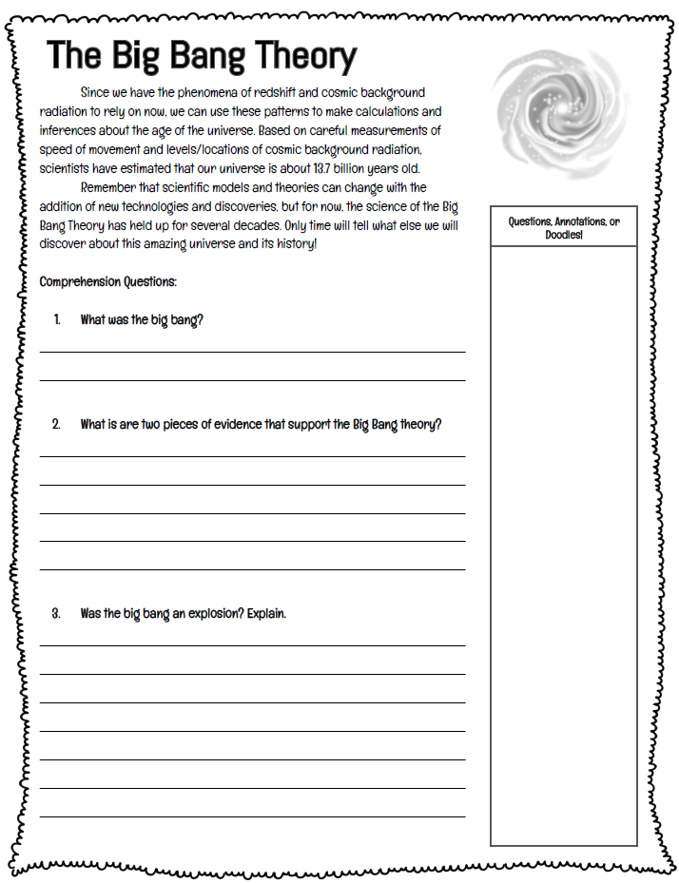
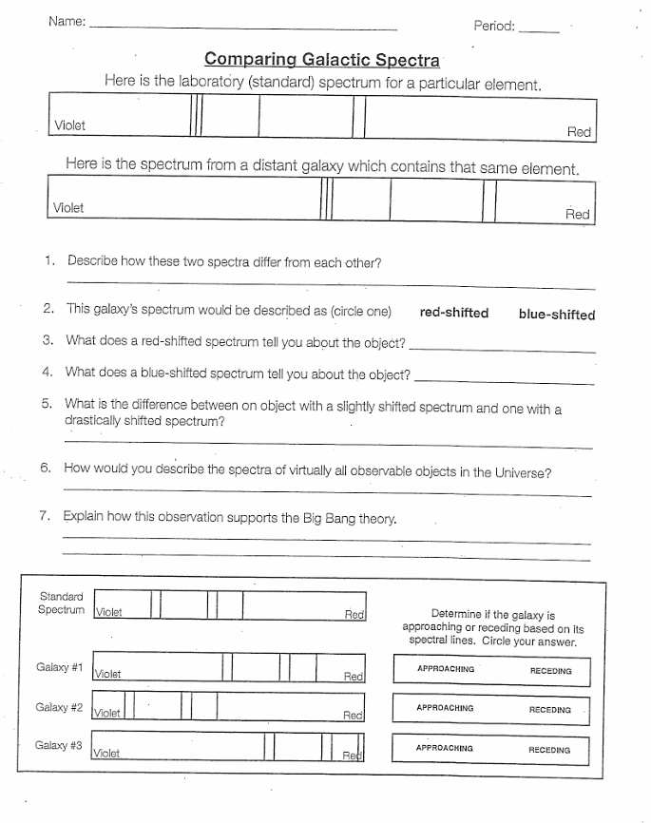
James Webb Space Telescope 2022 NOVA Documentary Name_______________________________Period_________
https://www.youtube.com/watch?v=350IrDnY0rk “Beyond Hubble, Launching the Telescope of Tomorrow” 42min

- When did the James Webb Space Telescope launch?

- Describe the photo known as “the Hubble Deep Field”

- How long does it take light to travel from the Sun to the Earth?

- What about the light from Proxima Centauri (the closest star to our Solar System)?

- What part of the telescope needs to big if it is to be “sensitive”?

- What was the problem with having a mirror 21 feet in diameter (on the James Webb Telescope)?

- What was the solution to getting such a large mirror in space (How did they end up designing the mirror)?

- T / F The James Webb detects heat waves, because the visible light from such distance galaxies is hard to detect.

- How does light change as it travels through space and time?

- T / F The James Webb telescope has the ability to “see” (the infrared heat signature) of a bumble on the moon

- How did they solve the problem of the Sun heating up the James Webb telescope? Another words, what did they engineer to keep the telescope cool so it could detect faint heat signatures?

- The James Webb telescope does not orbit the Earth like Hubble. Where will it be in space?

- What substance was used to coat the mirrors?

- T / F The James Webb Telescope should give us information on how galaxies and black holes formed.

- When was the primary mirror completed (month and year)?

- T / F The James Webb telescope has multiple scientific instruments but they can only be used one at a time.

- Why does NASA have to make sure James Webb is right and works flawlessly the first time it’s deployed?

- What is an exoplanet?

- What will the James Webb telescope do to help us find out if life exists on an exoplanet?

- How many layers make up the sun shield?

- How expensive is the James Webb Space Telescope?

- How long did it take to “unfold” and set up the telescope?

- When will Webb get the first images sent back to Earth?

- If Webb was launched on 25 December 2021, when will the first images be revealed to the public (pick one)?
Mid-December 2022 / early March 2023 / late May 2022 / we have already seen them

KEY
- When did the James Webb Space Telescope launch? Dec 25th, 2021 Christmas Day
- Describe the photo known as “the Hubble Deep Field” An image that showed thousands of galaxies
- How long does it take light to travel from the Sun to the Earth?
8 minutes
- What about the light from Proxima Centauri (the closest star to our Solar System)? 4.3 years
- What part of the telescope needs to big if it is to be “sensitive”? The main mirror
- What was the problem with having a mirror 21 feet in diameter (on the James Webb Telescope)?
The largest rocket could not fit the mirror inside it to launch it into space
- What was the solution to getting such a large mirror in space (How did they end up designing the mirror)? They used 18 hexagonal mirrors joined together, that could be folded up to fit in the rocket.
- T / F The James Webb detects heat waves, because the visible light from such distance galaxies is hard to detect. True
- How does light change as it travels through space and time? It expands or gets stretched out just like the universe itself, and becomes infrared light instead of visible.
- T / F The James Webb telescope has the ability to “see” (the infrared heat signature) of a bumble on the moon
True
- How did the solve the problem of the Sun heating up the James Webb telescope? What did they engineer to keep the telescope cool so it could detect faint heat signatures?
A sun shield was designed to keep the heat away
- What question did astronomers want to ask and solve (which was one of the goals of a space telescope)?
How old is the universe?
- The James Webb telescope does not orbit the Earth like Hubble. Where will it be in space?
The second La Grange Point, a stable orbiting area known as L2. It will actually orbit the Sun like Earth does.
- What substance was used to coat the mirrors? Gold
- T / F The James Webb Telescope should give us information on how galaxies and black holes formed.
True
- When was the primary mirror completed (month and year)? Feb 2016
- T / F The James Webb telescope has multiple scientific instruments but they can only be used one at a time.
False
- Why does NASA have to make sure James Webb is right the first time it’s deployed?
Because unlike Hubble, there is no way to repair it if it’s found to be broken or damaged.
- What is an exoplanet?
A planet outside out own Solar System.
- What will the James Webb telescope do to help us find out if life exists on an exoplanet? It will look for bio-markers within the atmosphere of the exoplanet.
- How many layers make up the sun shield? 5 layers
- How expensive is the James Webb Space Telescope?
$10 billion dollars
- How long did it take to “unfold” and set up the telescope?
29 days
- When will Webb get the first images sent back to Earth?
6 months
- If Webb was launched on 25 December 2021, when will the first images be revealed to the public (pick one)?
Mid-December 2022 / early March 2023 / late May 2022 / we have already seen them.
late May 2022

